Devereux Center for Resilient Children: Early Childhood Initiative
Quarterly Newsletter for Summer 2011
This edition and past newsletters available for download from www.devereuxearlychildhood.org



International Mud Day –
Not Just for Children!

As many of you likely know, (and perhaps participated in), June 29th was International Mud Day. Hearing about this, I couldn’t help but think about nature-based, open-ended, messy play – and what a gift it is for children, especially for those children living in a technology-driven, hyper-structured world. Protective factors come in all forms, and one protective factor that is discussed over and over in the research and literature on resilience is that of offering opportunities for safe, open-ended exploration for children.

In honor of International Mud Day, I was invited by friends to enjoy a spa experience involving a mud bath. This experience was a first for me, and I was a little hesitant to allow myself to be completely immersed in something I have spent my life trying not to get all over me. I decided to try this new experience, and let me tell you, I remembered how it felt to be a kid. It was an amazing feeling just being covered head to toe (literally!) in mud, and the laughs my friends and I had are some that I will never forget. As much as you might get a kick out of a picture of me in my mud bath, I wanted to share a picture of a staff member’s child and a friend getting ready to jump in the mud.

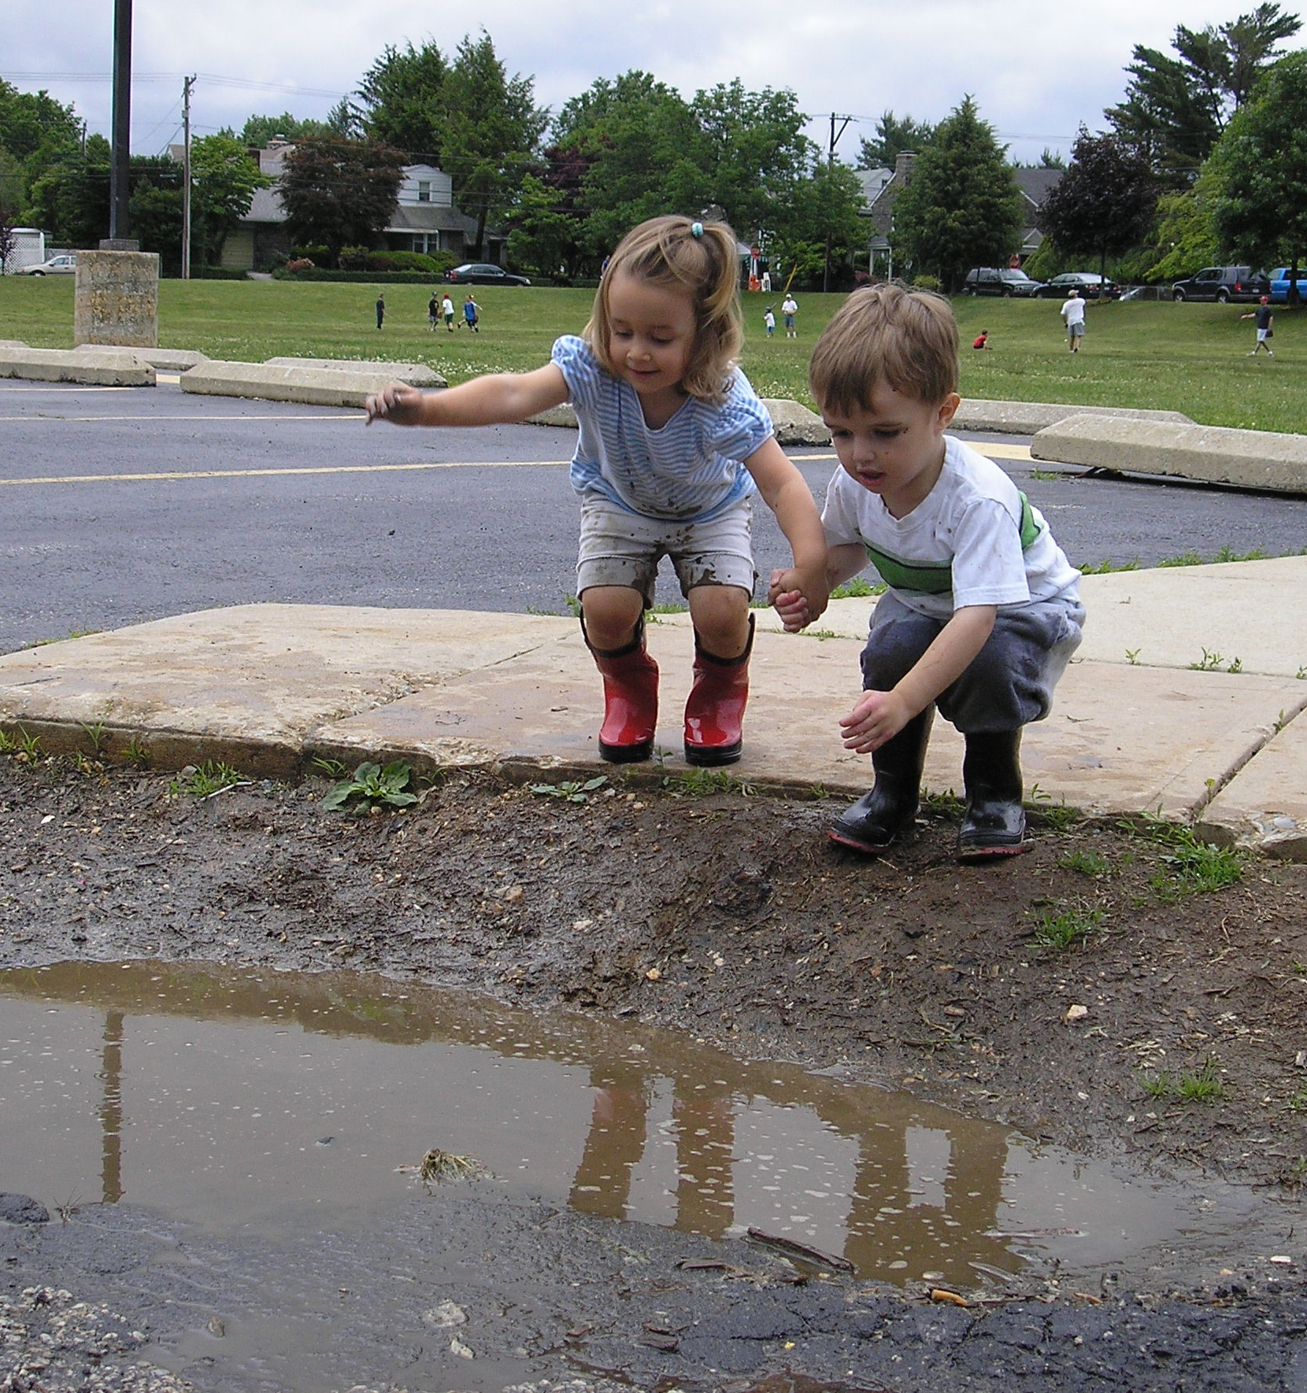

In this newsletter, we offer a few features that discuss a child’s right to explore. Be sure to check out the excerpt of an article by Sara Coten on allowing children to “struggle” in their exploration, as well a wonderful resource in the Recommended Resources segment of the newsletter by the Bernard Van Leer Foundation on a “Child’s Right to Play”. Additional information on protective factors across the ages as well as resilience-building ideas is offered through the International Resiliency Project at:
http://resilnet.uiuc.edu/library/grotb95b.html

Remember to celebrate and offer these play experiences to the children, not just on International Mud Day, but throughout the year. Finally, I would encourage you to treat yourself to some nature-based, open-ended, messy play soon!

Linda K. Likins, National Director

In this issue…
Page 1: Letter from the DECI Director
Page 2: What’s New at DCRC?, LPM News
Page 3: Featured Program from MD, I Faced the Challenge
Page 4: Teacher/Parent Conference, Building Your Bounce
Page 5: New CD, WA ECEAP Program, Research Corner
Page 6: Useful Resources on Social and Emotional Health
Page 7: Useful Resources (continued)
Page 8: Professional Development Opportunities

Just For Fun: Any Poets Out There?
Looking for a fun distraction this summer? Write a short poem about the DECI resources or your experience with them, and be entered to win the DECI resource of your choice! (Ranging from a DECA Kit, to the Facing the Challenge DVDs, to a Protective Factor Kit!)
Please limit submissions to a maximum of 150 words and email to Karen Cairone at kcairone@devereux.org by August 30th, 2011. Select submissions and our winner will be published in the Fall 2011 newsletter.
What’s New at the Devereux Center for Resilient Children (DCRC)?

Follow us on Twitter
The Devereux Center for Resilient Children has launched a twitter handle: @BuildURBounce. Please follow us as we use this forum to highlight resilience-promoting strategies and techniques. The tweets will show families and teachers how to help children “build their bounce” to cope successfully with risk and adversity and recover from life’s setbacks. We will spotlight resources and provide a forum in which to share research and ideas to promote a resilient new generation.

Research Opportunity for Programs in the South
Are you an early childhood program in the South? If so, please consider participating in an important DCRC research this summer! We are looking for preschool programs in the South to get involved in studies related to the DECA revision. Parents and teachers who participate will receive a gift card to Target. To find out more information please contact Katherine Ross at 610-542-3117 or kross@devereux.org

Socially Strong Emotionally Secure *A New Resource for Parents and Teachers*
The Devereux team is thrilled to announce the availability of a brand new resource for both teachers and parents to promote young children’s resilience. Socially Strong, Emotionally Secure provides 50 activities that help the adults in a child’s life promote resilience and social and emotional development through fun, engaging activities. Organized into five chapters, the activities support and build resilience in children ages 3 to 8. To learn more about this new resource, please visit: www.gryphonhouse.com. Watch a video clip of one of the activities in action at www.devereuxearlychildhood.org

Spanish Infant/Toddler Parent guides NOW AVAILBLE
Programs serving Spanish speaking families will be delighted to learn that the DECA for Infants and Toddlers For Now and Forever parent guide is now available in Spanish. The resource is available through our publisher, Kaplan Early Learning Co. To learn more, visit www.kaplanco.com and type the item #20338 into the search field.

e-DECA2.0 Purchasing Calculator
The web-based assessment platform, e-DECA2.0, is a wonderful tool, allowing programs to screen and assess children in a more effective, efficient manner. In efforts to make the e-DECA2.0 cost effective, two different purchasing options are available. Kaplan has created a purchasing calculator to support customers in understanding which option is the most cost effective based on their intended use of the system. If you are interested in accessing the purchasing calculator, please visit Kaplan’s website at www.kaplanco.com and type “purchasing calculator” into the search field.

Local Program Mentor (LPM) News

Congratulations New Devereux Recognized LPMs!

Brandon Schuerer
Eau Claire, WI

Exclusive LPM Resources are available in the LPM section of the DECI website:

New this month: Celebrate the strengths in all of us with an inspirational power-point for use in trainings. Add music to the file (with permission of course!) for an exciting and sentimental experience for training participants.
www.devereuxearlychildhood.org.

Excerpts from “The Importance of Letting Children Struggle”
By: Sara E. Cotner

“What do children learn when they are given the freedom to struggle with challenges? Well, first of all, they develop themselves at a pace that is more in line with their potential. Secondly, children who are allowed to struggle with challenges learn that they can work hard and overcome those challenges.”

“I think the two biggest hurdles to letting children struggle are awareness and time/patience. First, we have to observe our children and know what is within an appropriate range of struggle. We have to seek out opportunities for them to do work that is within this range. Secondly, we have to slow down and be patient as they struggle.”
Read more: http://www.feedingthesoil.com/2011/06/importance-of-letting-children-struggle.html

Featured Program   | Wicomico County Public School System  Submitted by:  Sandra L. Drummond, drummond@wcboe.org  and, Holly Hatton, hhatton@wcboe.org
Wicomico County Public School System (WCPS) is a diverse public school system located on the Eastern Shore of Maryland. WCPS serves approximately 1774 Pre-Kindergarten and Kindergarten students from rural, suburban and urban areas in twelve different sites. In addition, the Wicomico Early Learning Center houses a full-day program which serves 38 three year olds.

Both Sandra Drummond, Supervisor of Early Childhood, and Holly Hatton, Supervisor of Elementary Special Education, noted that a growing number of Pre-K and K students in the county were being suspended or referred to special education for challenging behaviors.

During the 2008-2009 school year, 164 pre-kindergarten and kindergarten students received office referrals with 36 of the referrals resulting in out of school suspensions.

Noting this, the pair looked for an avenue to address the concern while support school-based personnel. The supervisors were invited to participate in a DECA training opportunity sponsored by the Lower Shore Child Care Resource Center. The supervisors attended, met Rachel Sperry, a DECI Trainer, and a light bulb went off! Realizing that DECA would help to support the social-emotional needs of young children, the supervisors worked to garner the financial support of other departments within the Board of Education and the Maryland State Department of Education. The departments collaborated to provide the funding needed to develop, implement and train local personnel to support the DECA initiative.

Wicomico County students have benefited as a result of these efforts.

As of June, 2011, only 82 Pre-Kindergarten and Kindergarten students had office referrals with 33 of those resulting in out of school suspensions. This represents a significant decrease in the number of office referrals. WCPS hopes to see a continual decrease in the number of office referrals and out of school suspensions.

Both supervisors will continue to monitor the data, refine the district’s implementation procedures and provide support to the teachers and staff within the system.

I Faced the Challenge
By: Carrie Naijar, M. Ed., Early Childhood Education Specialist, STG International, Inc, Alexandria, VA.
I became a Center Supervisor at a Head Start program and focused on the academic outcomes of the children , supporting families with wrap-around services and assisting the teaching staff with occasional behavior issues. It seemed like there was not anything I could not handle. Two years later, I met my challenge, learning more about children’s behavioral language in nine months than I had learned in years of college.
Our center had three children that engaged in challenging behavior ranging from hitting other children and staff, knocking over furniture, dumping storage bins, ripping children’s artwork off the walls to collapsing on the carpet sobbing. I, with a Master’s degree, was expected to lead and support the teaching staff in addressing these behaviors, but did not know what to do. I was indebted to the mental health consultant’s leadership and her assistance in our center. One year later, she introduced me to a training opportunity that would change everything.
I attended the Facing the Challenge Train-the-Trainer program that the mental health consultant had invited me to attend. I was trained by Barbara Kaiser and Nefertiti Bruce, both knowledgeable trainers that shared similar classroom experiences. The training was in-depth, research based and made sense. The training videos and materials were relatable, sent a consistent message and incorporated the work of numerous experts in the field of Early Childhood. I left the training program with answers and resources; the pieces of the puzzle I needed!

Since 2007, I have delivered Facing the Challenge training to over 400 participants in Ohio. After attending this training, educators leave with the understanding that challenging behavior is a language children speak in times of need, not because they are “bad kids.” Facing the Challenge reminds us that addressing challenging behavior is a journey, not a day trip. Now my journey begins every time I lead a training and share my experiences. At the end of every training I take pride in knowing, I faced the challenge.

To learn more about Facing the Challenge Train the Trainer sessions, contact dmahler@devereux.org or visit our professional development section of our website on www.devereuxearlychildhood.org

You have to see these videos! “Early Learning Matters” and "Change the First Five Years and You Change Everything" and other advocacy videos are available on the First Five Years Fund website at www.ffyf.org

Contribution from one of our
DECI Certified Trainers

“Are We Talking About the Same Child?”
By: Julie P. Culhane, Ph.D., Certified DECI Trainer

Michael - a center-based educator
Justine - mother of a 2 1/2 year-old named Kadarro

After welcomes, we pick up a few minutes into the conference…

Michael: “Oh, I meant to remind you to bring your For Now and Forever book!”

Justine: “ I remembered! I almost didn’t bring it because to tell the truth, I haven’t looked at it since that meeting when you gave it to me and the other parents. Is that OK?”

Michael: “Of course, that’s fine. I know it’s difficult with 2 little children. We can look at it together today. And, before I forget, here’s that music CD I mentioned to you that has some of the songs Kadarro listens to by himself. The artist is David Kisor. When no other kids are around Kadarro listens for 5 to 10 minutes, and then asks me to sing one of the songs at circle. Even though Kadarro knows he can go there whenever he wants, he still asks if it’s OK!”

Justine: “Wait a minute. Are we talking about the same child? At home, when I try to get him to sit for a minute to look at a new book, or to ask his sister to play or sing, he just runs away. Then he asks me to get his guitar when it’s right next to him! And one more thing, he takes out my CDs when he knows he’s supposed to ask first.”

Michael: “I’m so glad you told me. It sounds like Kadarro is different at home than he is here. That’s true for many of the children! What’s important is that we’re both noticing what he likes to do, how he behaves everyday. Knowing so much about him helped us to fill out the DECAs.”

Justine: “The DECA? Is that the questionnaire that I did at the donut party? You called me the next day to ask me one of the questions again. Did I get it wrong?”

Michael: “No, you didn’t get it wrong, you just skipped one by mistake. There’s no right or wrong. The DECA paints a kind of “picture” of Kadarro that we’ll use today to plan some support.”

Justine: “What do you mean “support”? That makes me a little nervous.”
Michael: “It means planning some games or activities that we can work on here and you can do at home.”

Justine: “But how can we work together when Kadarro’s different at home than here? Isn’t that a problem?”

Michael: “No, it’s not a problem. When we put our information together, we get to see the whole Kadarro.

Michael and Justine look together through For Now and Forever and talk about the three protective factors.

Michael: “Making Kadarro as strong as possible in those three areas actually builds a kind of protection, so it’s less likely that his behavior will become a concern.”

Justine: “OK. I like that idea. How do we get started?”

Michael: “Well, your example was about the guitar, and mine was about the listening center. We both want him to take more initiative, so let’s start there.”

Justine: “And we both noticed he likes music. Maybe then he’ll pick up his guitar and sit for a while to sing?!”

Michael: The Songs of Resilience CD I handed you has fun songs about initiative, including, “I Can Do It” and “I Keep on Workin’ ‘til I Figure It Out”. How about we look in the For Now and Forever booklet for some other ideas?”

Justine: “Maybe we can find some books to borrow and bring home. I can put my CDs away and replace them with the books so he can get them when he wants.”

Michael: “Great idea. I’ll start writing our ideas down to remind us what we plan, and make you a copy to take with you today.”

Building Your Bounce

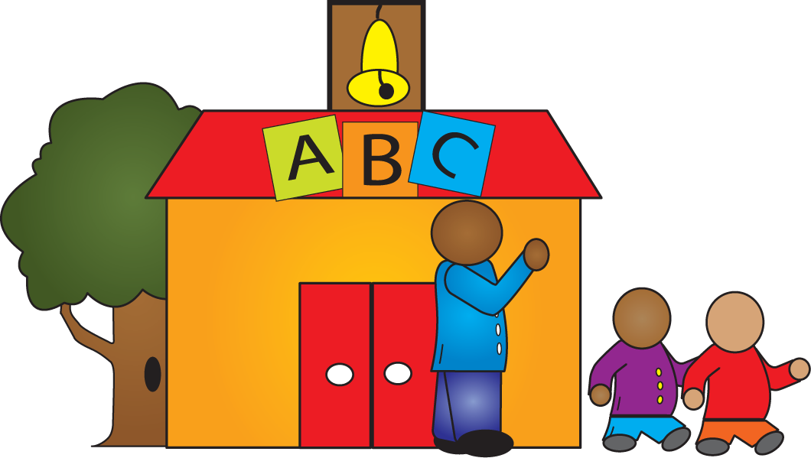

The following website offers suggestions help teachers refresh, rejuvenate, and essentially, build their bounce this summer. Enjoy!

http://www.edutopia.org/summer-rejuvenation-classroom-resource-guide

The Devereux Regional Center at Children, Inc. Creates a New Toddler CD: ‘Becoming My Own Me’
By: Tom Lottman, Research Director,
Growing Sound

The Devereux Regional Center at Children, Inc.’s Growing Sound project is excited to announce the release of a new album by David Kisor entitled, Becoming My Own Me. The music is designed to help children move from self-awareness to self assertion, and finally to self-control. As a child exercises his natural motivation to explore, and new found language to assert his own demands, the parent defines the boundaries that make his world safe and his place in it secure.

Located in Covington, Kentucky, The Devereux’s Growing Sound project develops music and other products that translate key findings from recent child development research into practical and entertaining products for teachers, parents, and children. Founded in 2007 as a new venture of Children, Inc., our products stimulate social and emotional development in a way that is fun for young children. While many products focus on managing children’s problem behaviors, Growing Sound, in the DECA tradition, is a proactive, strength-based approach to helping children discover the goodness in their lives and in themselves.

The direct link for purchasing Becoming My Own Me from the Kaplan Early Learning Company is:
http://www.kaplanco.com/store/trans/productDetailForm.asp?CatID=14|MV1000|0&PID=20525

Contribution from one of our
DECI Certified Trainers

DECA in Washington’s Early Childhood Education and Assistance Program (ECEAP)
By: Nicole Rose, ECEAP/Comprehensive Pre-K Specialist, and DECI Certified Trainer

Washington State’s Department of Early Learning (DEL) provides funding and oversight to the Early Childhood Education and Assistance Program (ECEAP), which currently serves more than 8,000 low-income three- and four-year-olds each school year. ECEAP offers preschool education, family support, parent involvement, and health and nutrition services that involve the whole family and helps prepare children for success in school and life.

The use of the DECA was written into the 2008 ECEAP Performance Standards, even though some contractors had used the tool for years. Beginning July 1, 2008, ECEAP contractors were required to use the DECA to assess children’s protective factors. Teachers complete the DECA twice per year, for each child.

DEL offers DECA training to ECEAP programs in the fall, and often invites other community early learning providers. During trainings ECEAP providers learn about resilience, protective factors and the five quality program elements (Reflective Checklists) as a foundation for ensuring a strong social-emotional learning environment.

In 2010-2011, ECEAP contractors transitioned to the e-DECA 2.0. In the 2009-2010 program year, 6,813 ECEAP children were assessed in both fall 2009 and spring 2010. The number of children with strong total protective factors increased from 19.2 percent in the fall to 36.9 percent in the spring. The number of children with total protective factors rated as “Concerns” was reduced from 7.2 percent of ECEAP children to 2.6 percent. ECEAP contractors also saw a decrease in children with behavioral concerns. In the fall, 9.5 percent of children experienced behavioral concerns. This number was 7.1 percent in the spring, with 151 children no longer experiencing behavioral concerns.

DEL looks forward to DECA results for the 2010-2011 school year as ECEAP contractors continue to sprinkle Initiative, Attachment and Self-Control throughout the daily routines in their classrooms!

Research Corner:

Parent-teacher agreement and reliability on the Devereux Early Childhood Assessment (DECA) in English and Spanish for ethnically diverse children living in poverty By: Jennifer Fleming, DCRC Research Assistant

The purpose of this study was to examine the reliability of the English and Spanish forms of the DECA with an ethnically diverse sample of preschoolers living in poverty. Social-emotional competence is especially important for these children due to the numerous risk factors they face. Therefore, it’s essential to ensure the DECA can be effectively used with this population. To address these points, child care teachers and parents rated a total of 7,756 preschool children (ages 3 and 4) who were enrolled in center-based child care programs and received child care subsidies for low-income families. The sample was ethnically diverse with 57% Latino/Hispanic, 38% African American/Caribbean islander, and 5% White/other. Parents and teachers completed the DECA (in their choice of English or Spanish) at the beginning of the academic year (September) and at the end of the school year (May). Children were also assessed on the Learning Accomplishment Profile – Diagnostic (LAP-D), a measure of cognitive, language, and motor skills, at both time points.

Results indicate that both the English and Spanish forms of the DECA are reliable measures of social-emotional competence and behavioral concerns. A moderate level of parent-teacher agreement was found which is consistent with previous research. Parents tended to rate their children as having stronger social-emotional competence and demonstrating more behavioral concerns compared to teachers. This finding supports the use of the DECA with both parents and teachers across diverse ethnic, language, and socioeconomic backgrounds. Furthermore, agreement was found to be higher when both parents and teachers completed the form in the same language. This finding may be important for programs serving bilingual families and teachers. Additionally, parent and teacher agreement differed based on the child’s cognitive, language, and motor skill competence as assessed by the LAP-D. Children with high-functioning competence were rated more favorably by teachers, while children with low-functioning competence were rated more favorably by parents. Taken together, the findings support the use of the DECA with English and Spanish speaking ethnically diverse populations living in an urban, impoverished environment.

Source: Crane, J., Mincic, M. S., & Winsler, A. (2011).
Parent-teacher agreement and reliability on Devereux
Early Childhood Assessment (DECA) in English and
Spanish for ethnically diverse children living in poverty.
Early Education & Development, 22, 520-547.

Newsletter submissions are always welcome! Contact newsletter editor, Karen Cairone, at Kcairone@devereux.org to share ideas, articles, questions, and resources. We send you thank you goodies!

Useful Resources on Social and Emotional Health and Resilience

Building Strong Systems of Support for Young Children's Mental Health
The National Center for Children in Poverty (NCCP) has published a new report that describes key strategies for creating a comprehensive system of supports for young children's mental health. It provides examples from states using these strategies and includes a tool that state planners can use to assess progress and plan steps toward building a strong system of early childhood mental health supports. Building Strong Systems of Support for Young Children's Mental Health: Key Strategies for States and a Planning Tool (June 2011), by Sheila Smith, Shannon Stagman, Susan Blank, Christine Ong, and Kendra McDow is available online at http://www.nccp.org/publications/pub_1016.html
New Resources from the Center for Early Childhood Mental Health Consultation
The Center for Early Childhood Mental Health Consultation recently published the following new resources:

- Tutorial: Recognizing and Supporting the Social and Emotional Health of Young Children Birth to Age 5
This tutorial provides early childhood mental health consultants with a detailed understanding of the behaviors related to social and emotional health in infants and young children, as well as strategies that adults can use to support these behaviors within every day routines and settings.
http://www.ecmhc.org/tutorials/social-emotional/index.html

- Infant Toddler Temperament Tool
This tool helps parents and caregivers explore their own temperament traits, as well as those of a child for whom they provide care. Results support parents and caregivers in understanding how adult and child similarities and differences in temperament traits may affect "goodness of fit" and provide tips to foster the unique temperament of each child within their care.
http://www.ecmhc.org/temperament/index.html

"Brain Hero" - A New 3-Minute Video from the Center for the Developing Child at Harvard University
The Center for the Developing Child at Harvard University has released a new 3-minute video entitled Brain Hero (2011) that adapts the visual sensibility of interactive game models to a video format. Based loosely on such games as “Guitar Hero,” “SimCity,” and “The Game of Life,” the video portrays how actions taken by parents, teachers, policymakers, and others can impact life outcomes for both the child and the surrounding community. For more, or to watch the video: http://developingchild.harvard.edu/library/multimedia/brain_hero/
Special Journal Section on Social-Emotional Issues in Early Childhood Settings
The Spring 2011 issue of Early Childhood Research & Practice (ECRP) is now available online. It contains a special section on Social-Emotional Issues in Early Childhood Settings. ECRP is a free online journal featuring articles related to the development, care, and education of children from birth to age 8. It is published by the Clearinghouse on Early Education and Parenting (CEEP) at the University of Illinois at Urbana-Champaign. Visit: http://ecrp.uiuc.edu/v13n1/index.html
Literature Review on Relationship-Based Learning

The link below offers many articles, research studies, and resources on relationship-based learning:
http://www.highreach.com/highreach_cms/LinkClick.aspx?fileticket=VAGBOBjbUr4%3d&tabid=70

CASEL Offers "SEL in Your State" Web-link

Click on a state and an age group to see relevant social emotional learning standards. http://casel.org/research/sel-in-your-state/

Updated Teaching Tools for Children with Challenging Behavior
The Technical Assistance Center on Social Emotional Intervention for Young Children (TACSEI) has updated its Teaching Tools for Young Children (TTYC) to include strategies for toddlers. The teaching tools give teachers practical strategies to create a plan to support young children who are having challenging behavior, including prevention, intervention, and response strategies. In addition, there is an expanded manual that includes using TTYC with toddlers, a decision tree, forms for teaming, tips for consultation to the classroom, and guidance on assessing implementation and outcomes. To learn more, go to http://www.challengingbehavior.org/do/resources/teaching_tools/ttyc.htm
Early Childhood Tool and State Policy Profiles from National Center for Children in Poverty
The National Center for Children in Poverty (NCCP) has released an online tool, The Young Child Risk Calculator, which shows users how many children under age six in each state are experiencing serious risks to their development. The tool allows users to select from three age groups: 0-3, 3-5, and 0-6, as well as three economic and various other risk factors known to affect children’s development. It is available online at http://www.nccp.org/tools/risk/
NCCP has also recently updated their Early Childhood State Policy Profiles, which provide a comprehensive view of state policies in the areas of health, early care and education, parenting and economic supports affecting the health and well-being of young children in low-income families. These can be accessed at http://nccp.org/profiles/early_childhood.html
Early Childhood Education Professional Development: Training and Technical Assistance Glossary
The National Association for the Education of Young Children (NAEYC) and National Association of Child Care Resource and Referral Agencies
(NACCRRA) announce the release of this new resources which is available at www.naeyc.org/GlossaryTraining_TA.org.
The definitions were developed for those who provide professional development, state policy makers, early education advocates, and program
administrators working to connect professional development activities and initiatives into an integrated system. The glossary is intended to
serve as a guide for states to adapt and adjust as needed to meet their specific needs. The definitions are also designed to provide common understandings, or starting points, for research and national or cross-state discussions.

Children’s Right to Play
This paper from Bernard Van Leer Foundation provides an examination of the importance of play in the lives of children worldwide. Wendy Russell and Stuart Lester of the UK's University of Gloucestershire argue that play is fundamental to the health and well-being of children, and that state signatories to Convention on the Rights of the Child - as well as adults more generally - should recognize, respect and promote play as a right. For more information, http://www.bernardvanleer.org/Childrens-right-to-play-An-examination-of-the-importance-of-play-in-the-lives-of-children-worldwide?pubnr=1274&download=1

“Play is the highest form of research.” ~ Albert Einstein



2011 DCRC Professional Development Opportunities  Contact: Debi Mahler Dmahler@devereux.org  or call (610)574-6141. | 

Spotlight on Professional Development – Technical Assistance
By: Debi Mahler, Professional Development Coordinator

High quality professional development on resources developed by the Devereux Center for Resilient Children helps to build the skills needed to support the overall healthy social and emotional development and reduce challenging behaviors in young children. Technical assistance provides additional opportunities to further hone these critical skills over time through coaching, troubleshooting, problem solving, and reflection. DCRC offers many options for technical assistance that can effectively fit into your schedule and budget. These include phone and/or webinar technical assistance, onsite technical assistance and troubleshooting, specialized technical assistance for Local Program Mentors, and more!

Phone and/or Webinar Technical Assistance:
Phone and/or webinar technical assistance services are personalized for your program needs. Technical assistance services can focus on a more in-depth look on a particular topic or around a list of unresolved questions and issues that staff may pose regarding implementation of DCRC resources. The audience for the technical assistance session(s) is selected by program staff and may include administrators, supervisors, consultants, teaching staff, or a combination of each. Technical assistance sessions are most effective when delivered in small groups.

Onsite Technical Assistance and Troubleshooting:
One of our DCRC Certified Trainer and Technical Assistance Providers can travel to your site and provide technical assistance one-to-one or in a small group setting. Technical assistance can be provided directly to a teacher within the classroom setting, with a detailed report sent to the program coordinator identifying strengths and goals for each classroom. Alternatively, technical assistance can be provided to a small group of teachers and/or administrators to address issues around implementation or overall issues related to the social and emotional development of young children.

Local Program Mentor Technical Assistance and Troubleshooting:
Our DCRC Certified Trainer and Technical Assistance Providers are available to offer additional support to your Local Program Mentor(s) on DECA/DECA-IT Program implementation as well as how to best offer technical assistance to those who are using the DECA/DECA-IT Program at your site. Technical assistance can be offered both via phone/webinar or at your local program.

For more information of Technical Assistance options for your program, please contact Debi Mahler, Professional Development Coordinator, at dmahler@devereux.org.

National Professional Development Opportunities in 2011

Dates | Training | Location
July 21-22 | 2-Day Building Your Bounce, Building Their Bounce Training: Promoting Resilience of Adults and Children | Raleigh, NC
September 28-29 | 2-Day DECA for Infants and Toddlers Implementation Training | Newport, KY  (Suburb of Cincinnati, OH)
September 30 | 1-Day Practical Resilience Building Strategies for Home and Caregiving Settings Training - Infant/Toddler | Newport, KY  (Suburb of Cincinnati, OH)
September 28-30 | 2.5-Day Facing the Challenge: Helping Teachers Better Work with Children with Challenging Behaviors Train-the-Trainer Session with Barbara Kaiser | Villanova, PA  (Suburb of Philadelphia)
October 17-18 | 2-Day DECA for Infants and Toddlers Implementation Training | Kansas City, MO
October 17-18 | 2-Day DECA Program Implementation Training | Kansas City, MO
October 19 | 1-Day DECA-C Training | Kansas City, MO
November 14-15 | 2-Day FLIP IT Train-the-Trainer Session | Villanova, PA  (Suburb of Philadelphia)

For more information or to register for any of these events, click here. (Link is http://www.devereux.org/site/PageServer?pagename=deci_training_dates) To schedule professional development for your local program/community on these or other topics related to promoting resilience in children and/or adults, please contact Debi Mahler, Professional Development Coordinator, at dmahler@devereux.org or (610) 574-6141.

